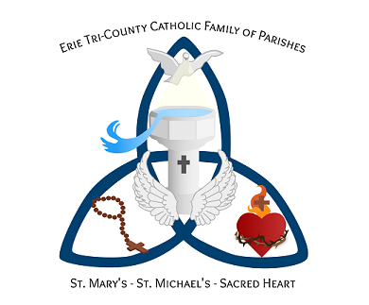
Erie Tri-County Catholic Family of Parishes
St. Mary’s – St. Michael’s – Sacred Heart

Happy November to all our school families!

Perhaps you have heard the news – but we have become a family of parishes! That means that we now serve St. Mary’s in Tillsonburg, Sacred Heart in Langton and St. Michael’s in Walsh! We have had to rethink how we can prepare for the sacraments here at the Erie Tri-County Catholic Family of Parishes since many of the activities we did in the past are just not permitted due to COVID restrictions. The good news is COVID has given us a shot in the arm to become more digitally savvy!

It has taken some time, but we can now offer online registration for sacraments! Its like signing up for music lessons, sports and art programs – you go on our website at https://etcfp.dol.ca/ and click on the Sacraments tab at the top and choose which Sacrament you want information for and to register your child. Here is what is available:

BAPTISM: If your child has not been baptized in the Roman Catholic faith and is 7 years of age and under you can click on Baptism to access all the information you need to register a child for baptism. Baptism is the initiating sacrament into the Christian life. To celebrate the sacraments of 1st Reconciliation & 1st Communion in grade two, and Confirmation in grade eight, Baptism is required. To find out more go to https://etcfp.dol.ca/baptism.

1st RECONCILIATION & 1st COMMUNION: This sacrament is normally celebrated in grade two. Baptism is required to register for these sacraments. Reconciliation & Eucharist are the two sacraments your child can receive again and again, and hopefully we will be able to provide opportunities in the school in the New Year. If your child is in grade two (and up), already baptized in the Catholic Church, and is ready to receive these beautiful sacraments please go to https://etcfp.dol.ca/fr-fhc for more information and to register. Your family will see three different sessions – Winter, Spring & Summer - for you to choose from. The deadline to register for the Winter Session is December 1st, 2020.

CONFIRMATION: This sacrament is normally celebrated in grade eight. Baptism is required to register for this sacrament. Confirmation seals the gifts of the Holy Spirit given to each of us at our Baptism. If you child is in grade eight (or in high school), already baptized in the Catholic Church, celebrated reconciliation and communion, and wishes to be confirmed in the Catholic faith please go to https://etcfp.dol.ca/confirmation for more information and to register. Your family will see three different sessions – January, March & May - for you to choose from. The deadline to register for the January session is December 1st, 2020.

Please head to our website – etcfp.dol.ca – to register for the sacraments and for information concerning Mass times, how to reserve a seat for Mass and so much more! Once your registration has been received you will be receiving a confirmation email with more information from Colleen Hanley (chanley@dol.ca), who is coordinating the preparation for the Sacraments for 2020-2021.

Peace and Blessings!
Father Ben Hugye & Father Thomas Kuriacko
Colleen Hanley

